 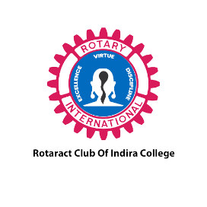 

**ROTARACT CLUB OF INDIRA COLLEGE**

**PDD AVENUE**

**RIY 2022-23**

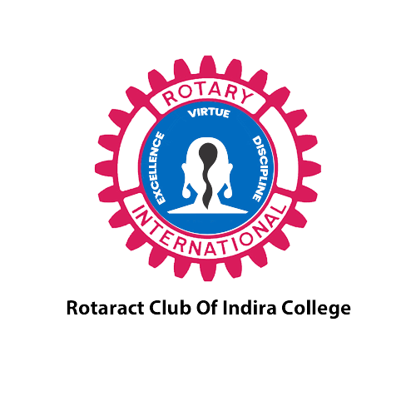

**Total Event: 06**

**Budget:-2909.5**

**Avenue Directors: -**

Rtr. Gunjan Chaudhari

Professional Development Director,

Rotaract Club of,

Zone 4 | RID 3131

INDEX

|  |  |
| --- | --- |
| Sr.No. | Particulars |
| 1. | Dues Receipt duly signed by Treasurer |
| 2. | Monthly Reports |
| 3. | Summary of Expenditure |
| 4. | Upcoming Events |
| 5. | Suggestions from ZR’s + Council Panel |

# JULY

# 2022

## Namaste Spain

**Date:** *11th July 2022*

**Details:** On the 8th of August, We Rotaract Club of Indira College conducted 𝙉𝘼𝙈𝘼𝙎𝙏𝙀 𝙎𝙋𝘼𝙄𝙉🇪🇸 in collaboration with Rotaract Club of Pune Pride ⭐ jointly by our club's Professional Development Director, Rtr. Gunjan Chaudhari & International Service Director, Rtr. Adharsh Nair, in which the mentor was Prachi Ahuja who is a 𝙎𝙥𝙖𝙣𝙞𝙨𝙝 language expert, where everyone gained some linguistic wisdom👩‍🏫.

**Attendance:** *70 members*

**PR Link:** https://www.instagram.com/p/CjA-FVWDo0r/?utm_source=ig_web_copy_link

**Event Photos:**

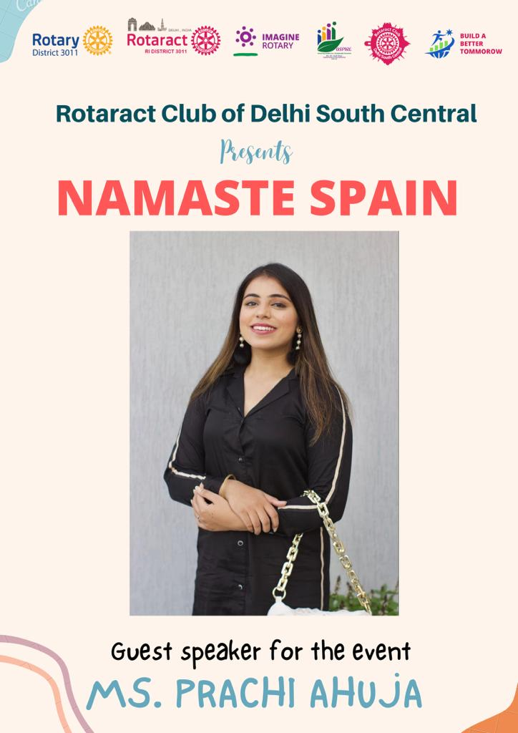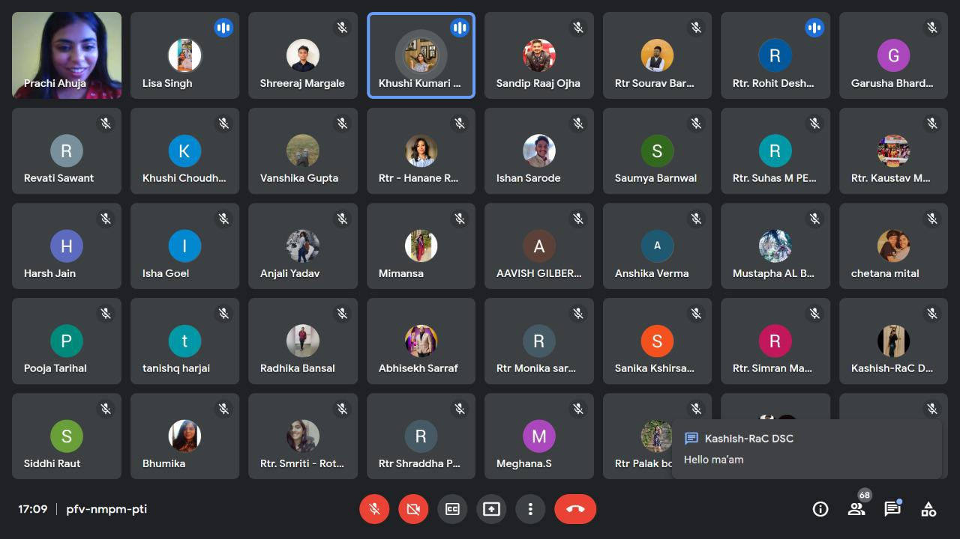

# AUGUST 2022

## Emotional Intelligence and Conflict Management

**Date:** *20th aug2021*

**Details:** 𝙀𝙢𝙤𝙩𝙞𝙤𝙣𝙖𝙡 𝙄𝙣𝙩𝙚𝙡𝙡𝙞𝙜𝙚𝙣𝙘𝙚 𝙖𝙣𝙙  
𝘾𝙤𝙣𝙛𝙡𝙞𝙘𝙩 𝙈𝙖𝙣𝙖𝙜𝙚𝙢𝙚𝙣𝙩 where 𝘌𝘟𝘗𝘌𝘙𝘐𝘌𝘕𝘊𝘌, 𝘐𝘘 🧠𝘢𝘯𝘥 𝘛𝘦𝘤𝘩𝘯𝘪𝘤𝘢𝘭 skills🖥️ are important, but intelligence and conflict management are becoming one of the important attributes for success in career.The session was taken by 𝙍𝙩𝙣. 𝙎𝙢𝙞𝙩𝙖 𝙑𝙞𝙠𝙝𝙖𝙣𝙠𝙖𝙧 which served as a great impact on all the audience

**Attendance:** *40+ members*

**PR Link:** https://www.instagram.com/p/CjXhn-6A4Ot/?utm_source=ig_web_copy_link

**Event Photos:**

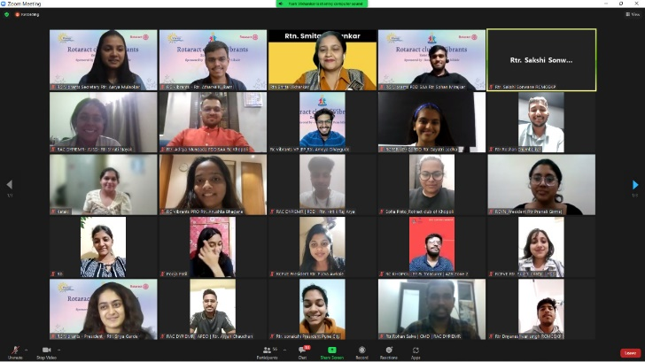

## Samvaad

**Date:** *24th aug2022*

**Details:** The value of what you are bringing to the audience is being judged.” On the 20th of August, We Rotaract Club of Indira College conducted Public Speaking Session with GBM, topics was given by the pdd every group had to speak something on that topic.

**Attendance:** *20+ members*

**PR Link:** https://www.instagram.com/reel/CjaO40XAxyf/?utm_source=ig_web_copy_link

**Event Photos:**

## 

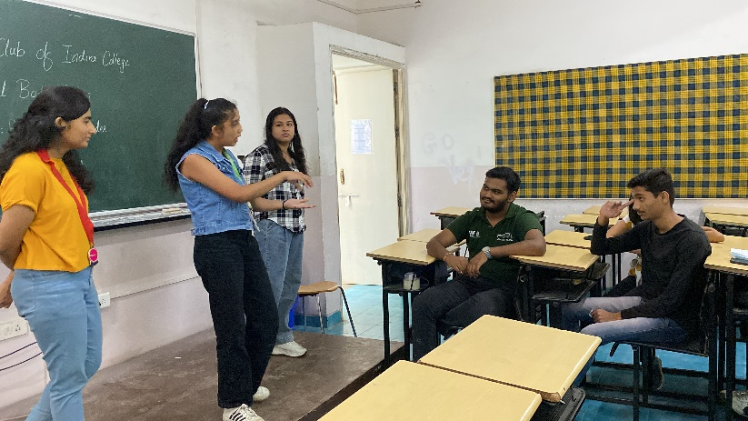

# September 2022

## National War Memorial

**Date:** *6th sep 2022*

**Details:** Visit to National War Memorial Southern Command. The Material which was used in war and guns,rifle was kept there and Maratha empire, many more empire was their

**Attendance:** *10+ members*

**PR Link:**

**Event Photos:**

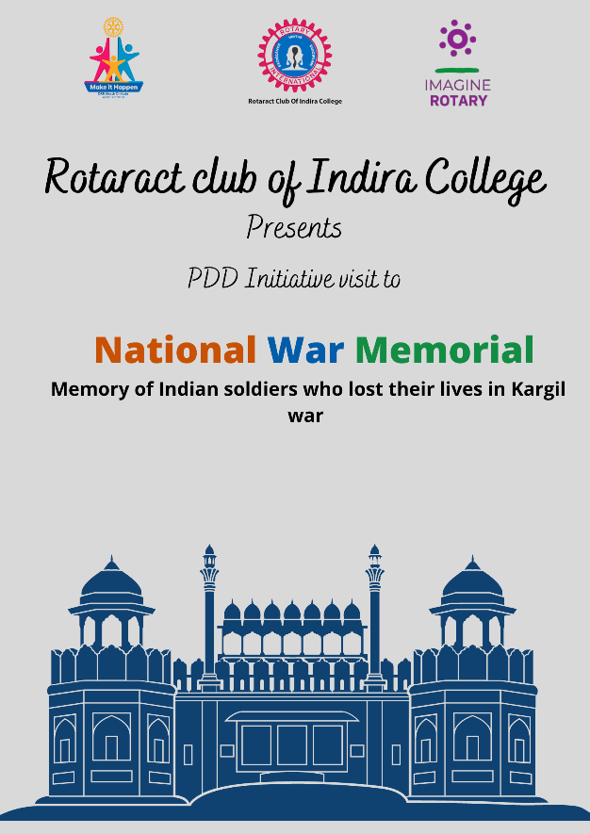

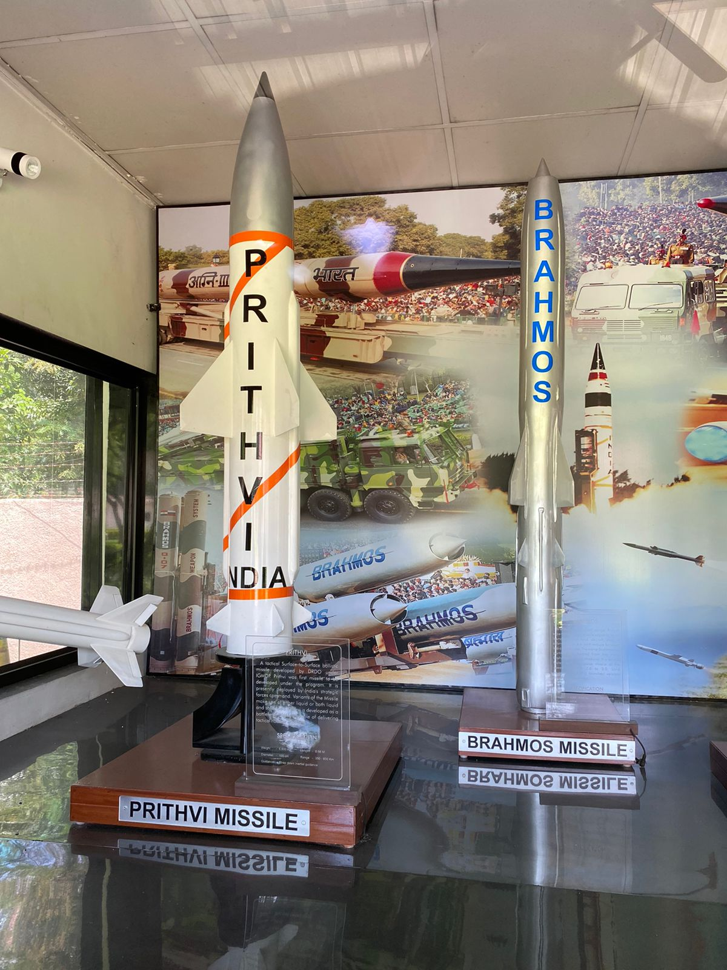

**Upcoming Events**

1. **LinkedIn Session**
2. **Handmade paper factory**
3. **Stock Market Session**
4. **Debate Competition**
5. **Discussion on various fraud cases**
6. **Knowledge Exchange event**
7. **Photography Session**
8. **Chocolate making Workshop**